Study Quest User guilde
no need to install , just go tohttps://frontend-beta-ten-26.vercel.app/login you can use it on phone , pad and computer
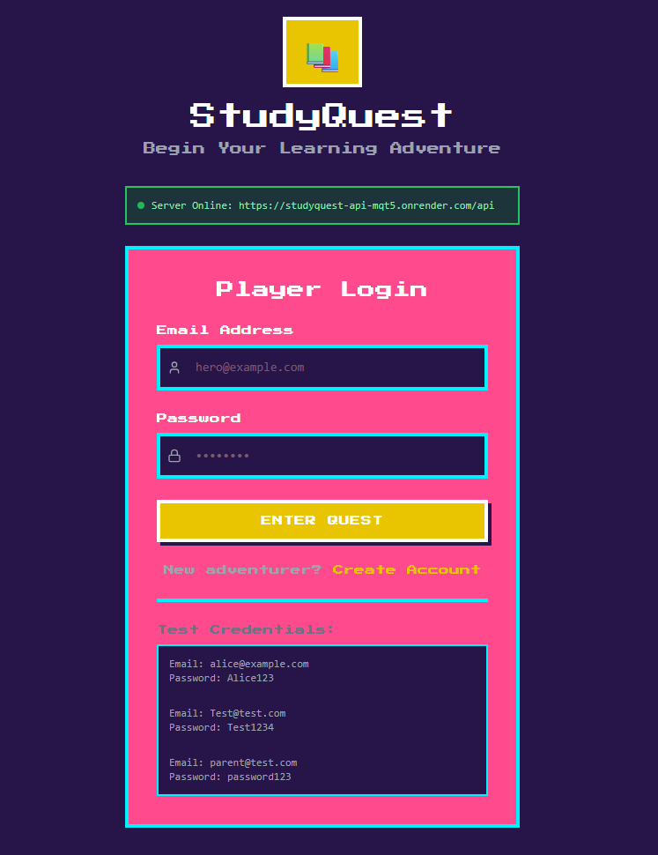
1. Login Screen — "Begin Your Learning Adventure"
What this screen does:
This is the front door to StudyQuest. Enter your email and password to start your study journey. If you don't have an account yet, you can create one here.
How to Use:

Open the app — Go to the StudyQuest website in your browser (Chrome, Safari, etc.)
Check server status — Look for the green "Server Online" bar at the top. If it's green, you're good to go
Enter your email — Tap the "Email Address" box and type your email (e.g., alice@example.com)
Enter your password — Tap the "Password" box and type your password
Tap "ENTER QUEST" — The big yellow button logs you in
First time here? — Tap "Create Account" to register as a new student or parent

Key Buttons & Features:

Email Address box — Where you type your login email
Password box — Where you type your secret password (shows dots for privacy)
ENTER QUEST button — Yellow button that logs you in
Create Account link — Orange text for new users to sign up
Test Credentials box — Demo accounts you can use to try the app:
Student: alice@example.com / Alice123
Student: Test@test.com / Test1234
Parent: parent@test.com / password123
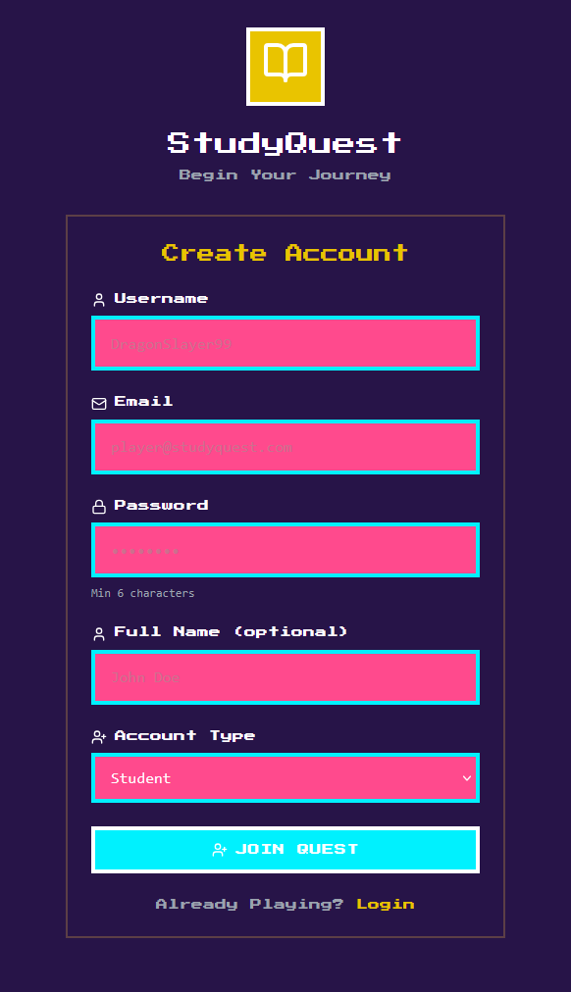
2. Create Account Screen — "Join the Quest"
What this screen does:
Make your own StudyQuest account. Choose if you are a student, parent, or teacher. This only takes 30 seconds.
How to Use:

Tap "Create Account" from the Login screen
Choose a Username — Type a fun name (e.g., DragonSlayer99). This is what friends will see on leaderboards
Enter your Email — Type a real email you can access (e.g., yourname@email.com)
Create a Password — Type at least 6 characters. Use letters and numbers to keep it safe
Enter Full Name (optional) — Your real name, if you want. You can skip this
Pick Account Type — Tap the dropdown:
Student — For students who want to track study time and earn XP
Parent — For moms/dads who want to see their child's progress
Teacher — For teachers who want to manage classes
Tap "JOIN QUEST" — The blue button creates your account and logs you in

Key Buttons & Features:

Username box — Your public name in the app
Email box — Used for login and password recovery
Password box — Must be 6+ characters (shown below the box)
Full Name box — Optional real name for parent/teacher identification
Account Type dropdown — Choose Student, Parent, or Teacher
JOIN QUEST button — Blue button to finish registration
Login link — If you already have an account, tap here to go back
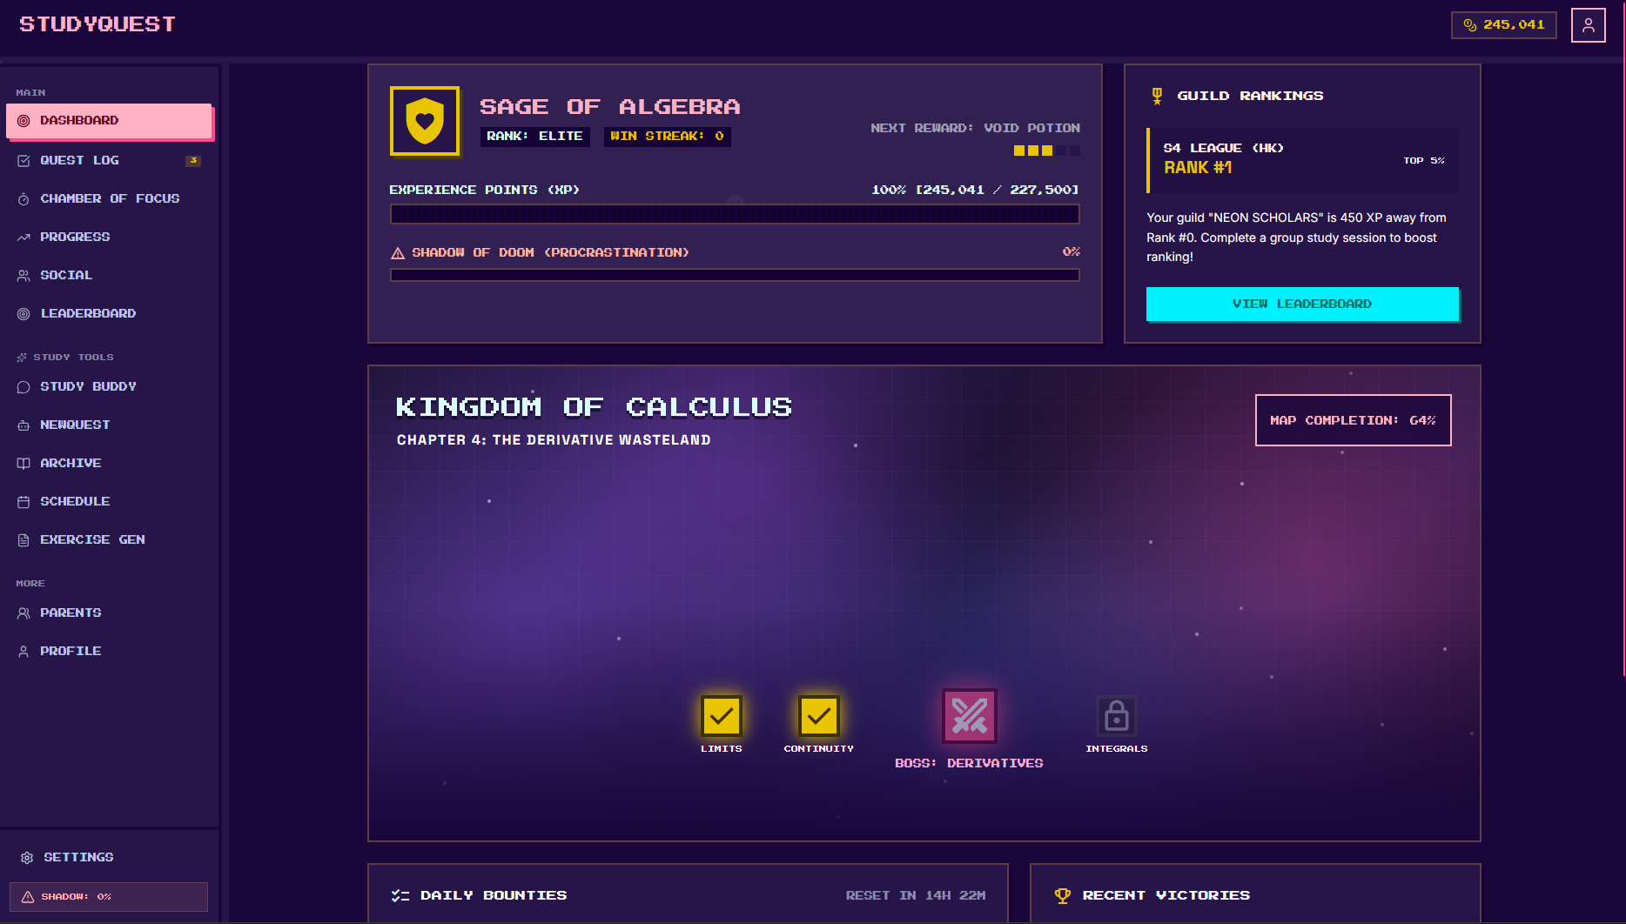
Check your stats (top center):

XP Bar — Shows your experience points (245,041). Fill this to level up!
Rank — Your current title (e.g., "ELITE")
Win Streak — How many days you've studied in a row (don't break it!)
Shadow of Doom — Red bar showing procrastination. Keep it at 0% by studying daily

Pick a subject to study (center map):

Kingdom of Calculus — Your current learning area
Chapter 4: The Derivative Wasteland — What you're working on now
Tap a topic icon to start studying that area:
Limits (yellow check) — You've completed this
Continuity (yellow check) — You've completed this
Boss: Derivatives (red swords) — Current challenge! Tap to fight the boss
Integrals (lock) — Locked until you beat the Derivatives boss

Check your guild ranking (top right):

See your rank in S4 League (HK) — currently #1!
"NEON SCHOLARS" is your study group
Tap "VIEW LEADERBOARD" to see full rankings

Start a study session:

Tap "CHAMBER OF FOCUS" in the left menu to start the study timer
Or tap any topic icon in the map to study that subject
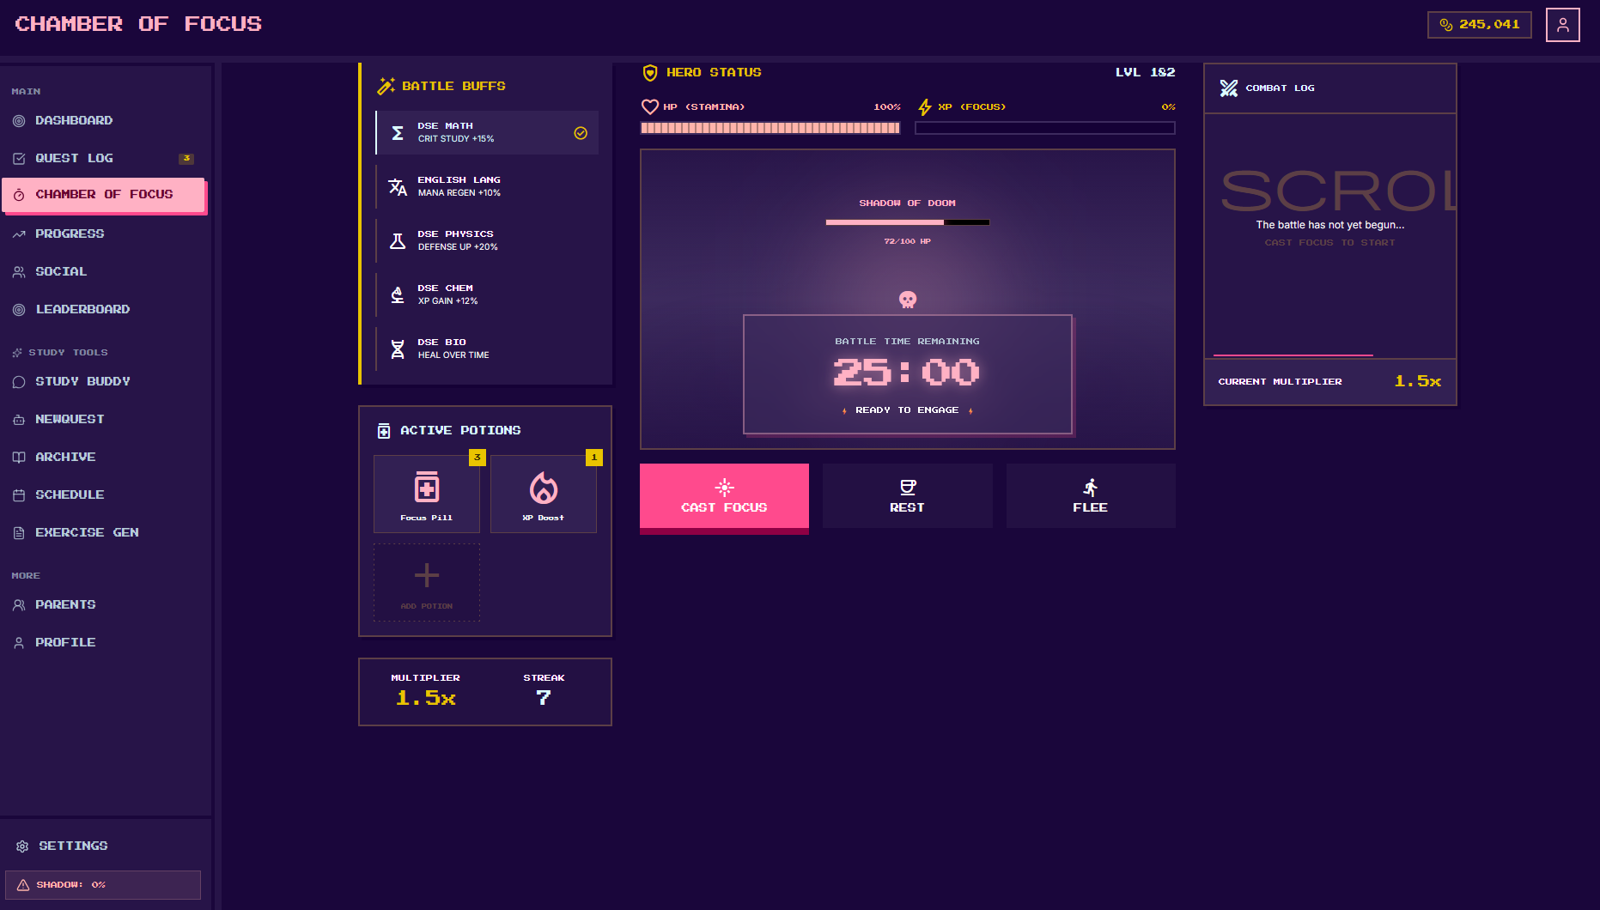
4. Chamber of Focus — "Start Your Study Battle"
What this screen does:
This is your study timer! "Fight" the Shadow of Doom (procrastination monster) by focusing for 25 minutes. The more you study, the more XP you earn and the weaker the boss gets.
How to Use:

Check your Battle Buffs (left side):
These are your subject bonuses. Each subject gives special powers:
DSE Math — Critical Study +15% (more XP!)
English Lang — Mana Regen +10% (faster recovery)
DSE Physics — Defense Up +20% (protects your streak)
DSE Chem — XP Gain +12%
DSE Bio — Heal Over Time
Tap any buff to see details or change your study subject
Check your Hero Status (top center):
HP (Stamina) — Your energy (100% = ready to fight!)
XP (Focus) — Fill this bar by studying
LVL 182 — Your current level
Shadow of Doom — The boss you're fighting (72/100 HP). Study to reduce this!
Use Potions (bottom left):
Focus Pill x3 — Tap to use a focus boost (keeps you concentrated)
XP Boost x1 — Tap to double your XP for this session
Add Potion (+) — Get more potions from the shop or achievements
Start the Battle (center):
Timer shows 25:00 — This is a Pomodoro session (25 minutes)
Tap the big pink "CAST FOCUS" button to start studying
The timer will count down. Keep working until it hits 0!
During the session:
Combat Log (right side) shows your battle progress
Current Multiplier 1.5x — Bonus XP multiplier (streak bonus!)
Streak 7 — You've studied 7 days in a row. Don't break it!
Need a break?
Tap "REST" to pause the timer (short break)
Tap "FLEE" to cancel the session (you'll lose this battle)
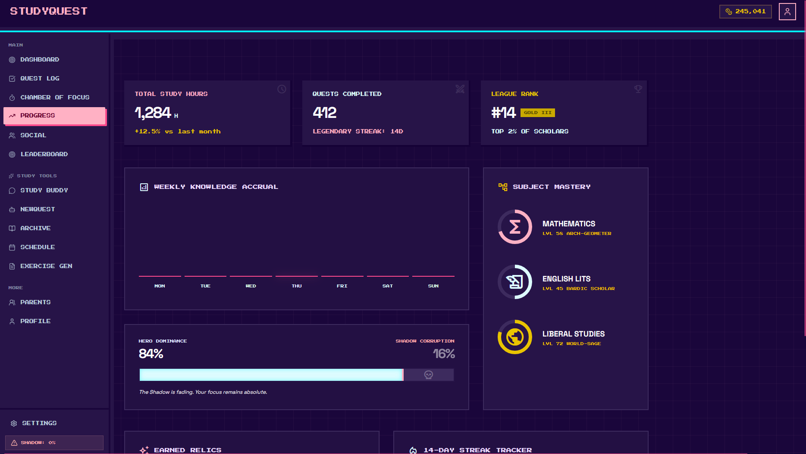
5. Progress Screen — "Your Study Statistics & Achievements"
What this screen does:
See your complete study history! Track how many hours you've studied, which subjects you're best at, and how you're doing against other students in Hong Kong.
How to Use:

Check your main stats (top row):
Total Study Hours: 1,284h — All the time you've ever studied (about 53 full days!)
+12.5% vs last month — You're studying more than last month. Good job!
Quests Completed: 412 — Tasks and study sessions finished
Legendary Streak: 14D — You've studied 14 days in a row without missing
League Rank: #14 — You're #14 in your school/region (Gold III tier)
Top 2% of Scholars — Only 2% of students study more than you!
Weekly Knowledge Accrual (middle left chart):
Shows which days you studied this week (Mon, Tue, Wed, Thu, Fri, Sat, Sun)
Longer bars = more study time that day
Check if you're studying consistently or cramming only on weekends
Subject Mastery (middle right):
See your level in each subject:
Mathematics — LVL 58 (Arch-Geometer title)
English Lits — LVL 45 (Bardic Scholar title)
Liberal Studies — LVL 72 (World-Sage title) — Your best subject!
The circular rings show how close you are to the next level
Tap any subject to see detailed progress
Hero Dominance vs Shadow Corruption (bottom):
Hero Dominance: 84% — Your power as a focused student
Shadow Corruption: 16% — Procrastination is weak right now!
Message: "The Shadow is fading. Your focus remains absolute." — Keep it up!
When Hero Dominance is high, you're winning. When it drops below 50%, the Shadow is taking over
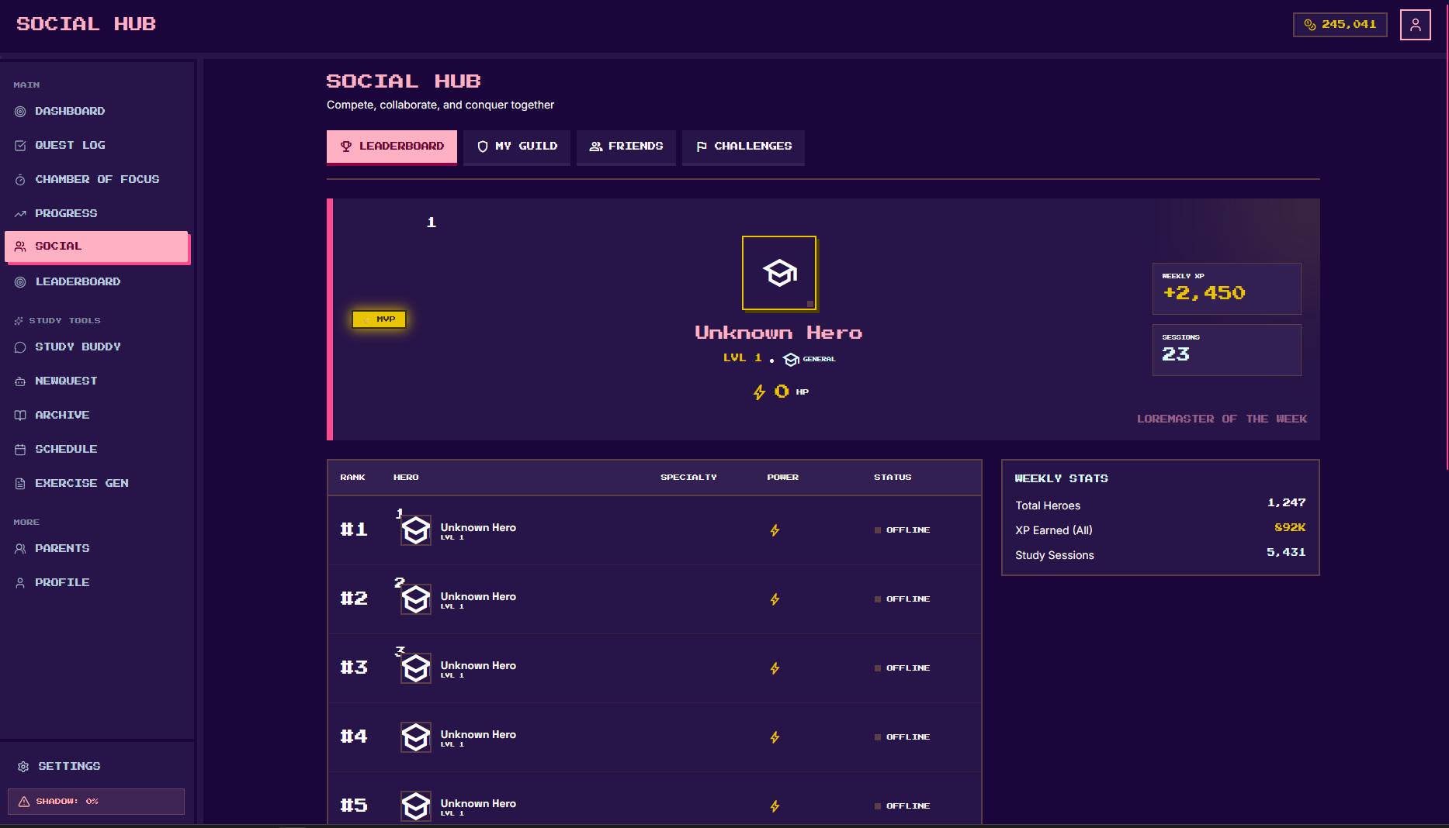
6. Social Hub — "Compete With Other Students"
What this screen does:
See how you rank against other students in Hong Kong. Join a guild (study group), add friends, and compete in challenges. Studying is more fun when you know you're winning!
How to Use:

Pick a tab (top buttons):
LEADERBOARD — You're here now. See rankings of all students
MY GUILD — Your study group (guild) members and group progress
FRIENDS — People you've added as friends
CHALLENGES — Special competitions (e.g., "Who can study the most this week?")
Check the featured hero (top center):
"Unknown Hero" — The #1 ranked student this week
MVP badge — Most Valuable Player (top performer)
Weekly XP: +2,450 — They earned 2,450 XP this week alone!
Sessions: 23 — They studied 23 times this week
"LOREMASTER OF THE WEEK" — Special title for the top student
Read the leaderboard (main table):
Rank #1 — The top student (currently "Unknown Hero")
Hero — Username and level (all showing LVL 1 in this example)
Specialty — Their best subject (empty in this view)
Power — Lightning bolt shows their activity level
Status — Online/Offline (all offline now)
Check weekly stats (right side):
Total Heroes: 1,247 — Total students using StudyQuest
XP Earned (All): 892K — All students combined earned 892,000 XP this week
Study Sessions: 5,431 — Total study sessions completed by everyone
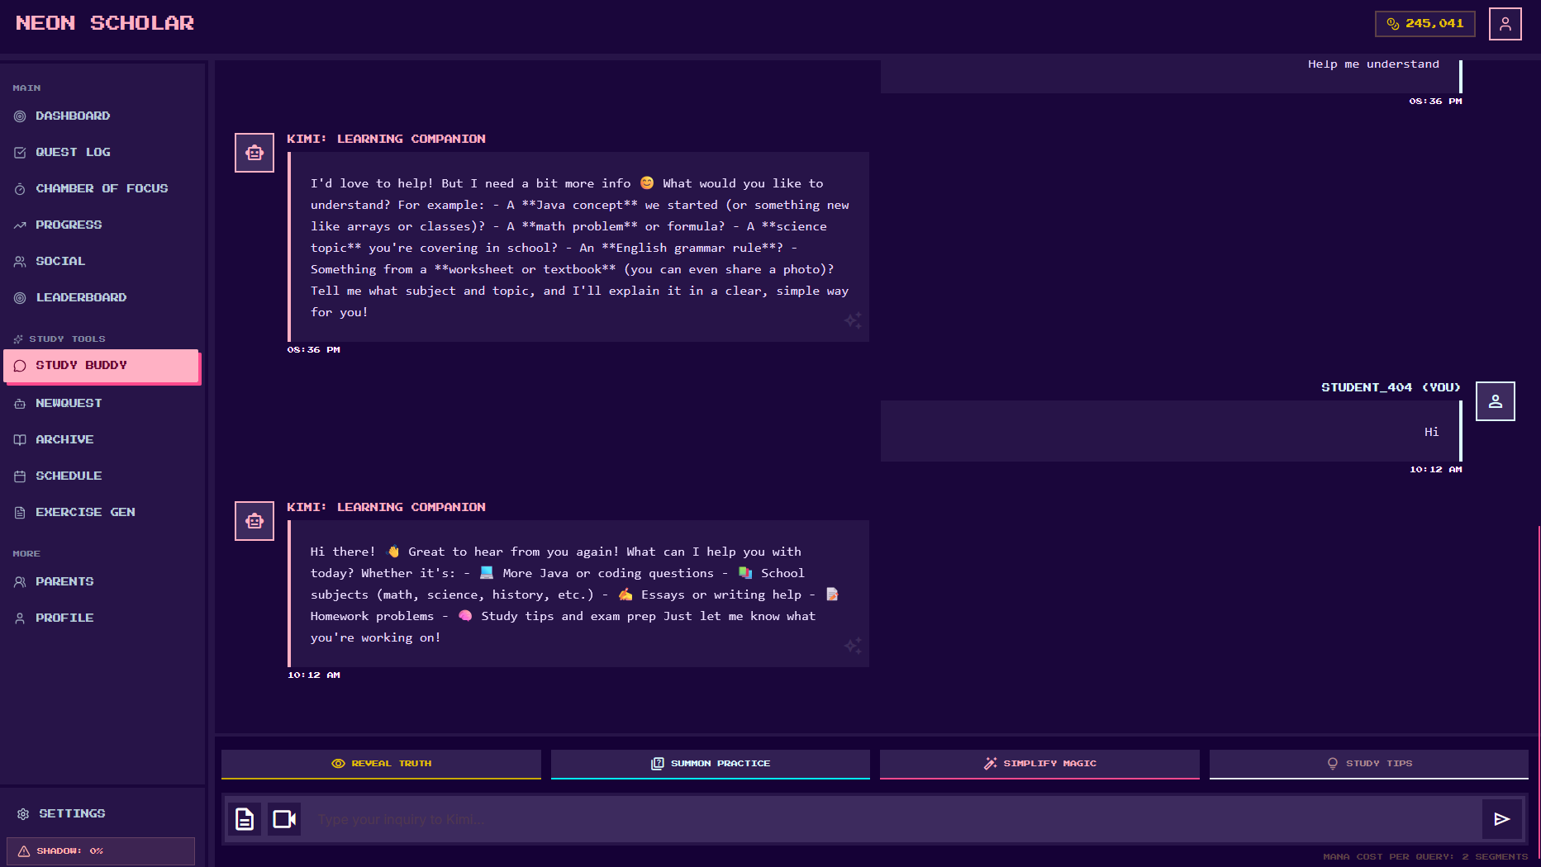
7. Study Buddy — "Ask Kimi Anything"
What this screen does:
Your personal AI tutor! Ask Kimi about homework, math problems, science concepts, English grammar, or coding. Kimi explains things in a simple way and won't just give you the answer (you have to learn!).
How to Use:

Open Study Buddy — Tap "STUDY BUDDY" in the left menu
Read Kimi's welcome — Kimi asks what you want to learn (Java, math, science, English, etc.)
Type your question — Tap the message box at the bottom and type:
"How do I solve x² - 4 = 0?"
"What is photosynthesis?"
"Help me understand Java arrays"
"Check my essay grammar"
Send your message — Tap the paper airplane button (or press Enter)
Wait for Kimi's reply — Usually takes 5-10 seconds
Keep chatting — Ask follow-up questions until you understand

The 4 Magic Modes (bottom buttons):

REVEAL TRUTH (Yellow) — Ask a question and get the answer explained step-by-step
SUMMON PRACTICE (Blue) — Generate practice problems/worksheets on any topic
SIMPLIFY MAGIC (Pink) — Make a hard concept easier to understand (great for confusing textbook pages!)
STUDY TIPS (Gray) — Get advice on how to study better, manage time, or prepare for exams

Send Attachments:

Document icon (bottom left) — Upload a photo of your homework or textbook page
Camera icon — Take a photo directly to ask about a specific problem
Kimi can read the image and explain what's in it!

Key Features:

Chat bubbles — Gray = Kimi (AI), Purple/Blue = You
Timestamps — Shows when messages were sent (08:36 PM, 10:12 AM)
Kimi icon — The robot face shows when Kimi is speaking
"STUDENT_404 (YOU)" — Your messages appear on the right side
Mana Cost: 2 segments — Each question uses 2 "mana" (energy). You have limited mana per day, so use questions wisely!
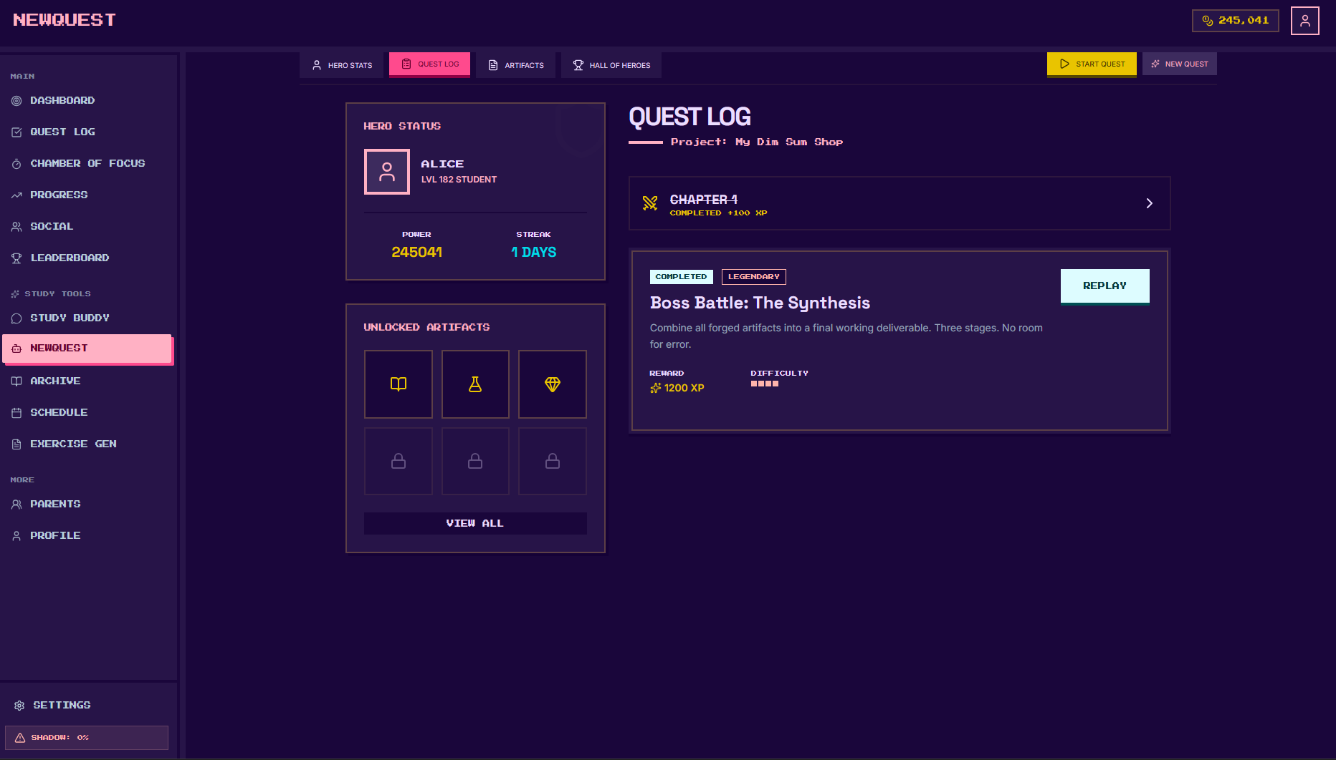
NewQuest / Quest Log — "Your Mission Control"
What this screen does:
Manage your study tasks and big projects here. See what you've finished, what artifacts (achievements) you've unlocked, and start new "quests" (assignments or study goals).
How to Use:

Check your Hero Status (top left):
ALICE — Your character name
LVL 182 STUDENT — Your current level
POWER: 245041 — Your total XP points
STREAK: 1 DAYS — Study today to make this 2!
View your Artifacts (bottom left):
These are badges/achievements you've earned
3 unlocked (book, potion, diamond icons) — You've earned these!
3 locked — Complete more quests to unlock these
Tap "VIEW ALL" to see every achievement in the game
Check your Quest Log (right side):
Chapter 4 — Completed! You got +100 XP
Boss Battle: The Synthesis — A big project you finished
Status: COMPLETED + LEGENDARY (means you did an amazing job!)
Description: "Combine all forged artifacts into a final working deliverable. Three stages. No room for error."
Reward: 1200 XP — Big reward for big effort!
Difficulty: 3 bars — Hard quest
Tap "REPLAY" to do this challenge again (practice mode)
Start a New Quest:
Tap the yellow "START QUEST" button (top right) to begin a task you've already created
Tap "NEW QUEST" to create a brand new study mission

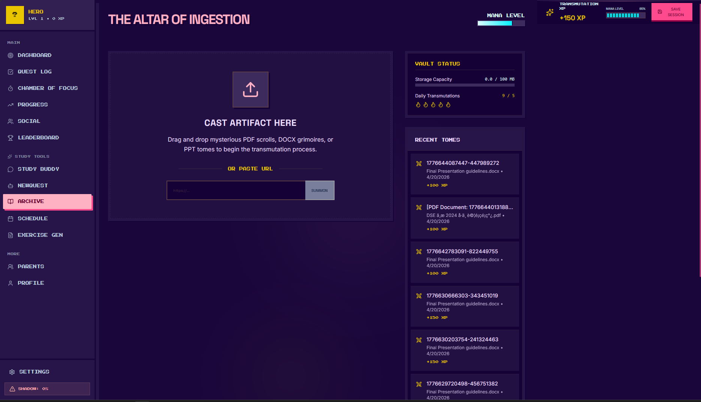
Archive Alchemist — "Upload Your Study Materials"
What this screen does:
Upload your homework, textbook pages, PDFs, or PowerPoints. The AI reads them and creates study notes, flashcards, and concept maps automatically. It's like having a robot summarize your books for you!
How to Use:

Open Archive — Tap "ARCHIVE" in the left menu
Upload a file:
Drag and drop — Drag a PDF, DOCX, or PPT file from your computer into the "CAST ARTIFACT HERE" box
Or paste a URL — Copy a web link (like a Google Doc or article) and paste it in the URL box, then tap "SUMMON"
Wait for processing — The AI reads your document (takes 10–45 seconds)
Get your results — The AI creates:
Structured notes — Organized summary of the document
Flashcards — Question-and-answer cards for memorization
Concept map — Visual diagram showing how ideas connect
Check Recent Tomes — Your uploaded files appear on the right side with XP rewards

Key Buttons & Features:

CAST ARTIFACT HERE — Big upload box in the center. Drag files here!
OR PASTE URL — Type a web link instead of uploading a file
SUMMON button — Starts the AI processing after you paste a URL
Vault Status (top right):
Storage Capacity — How much space you've used (e.g., 0.4 / 100 MB)
Daily Transmutations — How many documents you can process today (e.g., 3 / 5)
Recent Tomes — List of your previously uploaded documents
Shows filename, date, and XP earned (+150 XP, +500 XP, etc.)
Mana Level — Your energy for using AI features
+150 XP — You earn XP just for uploading and learning from documents!
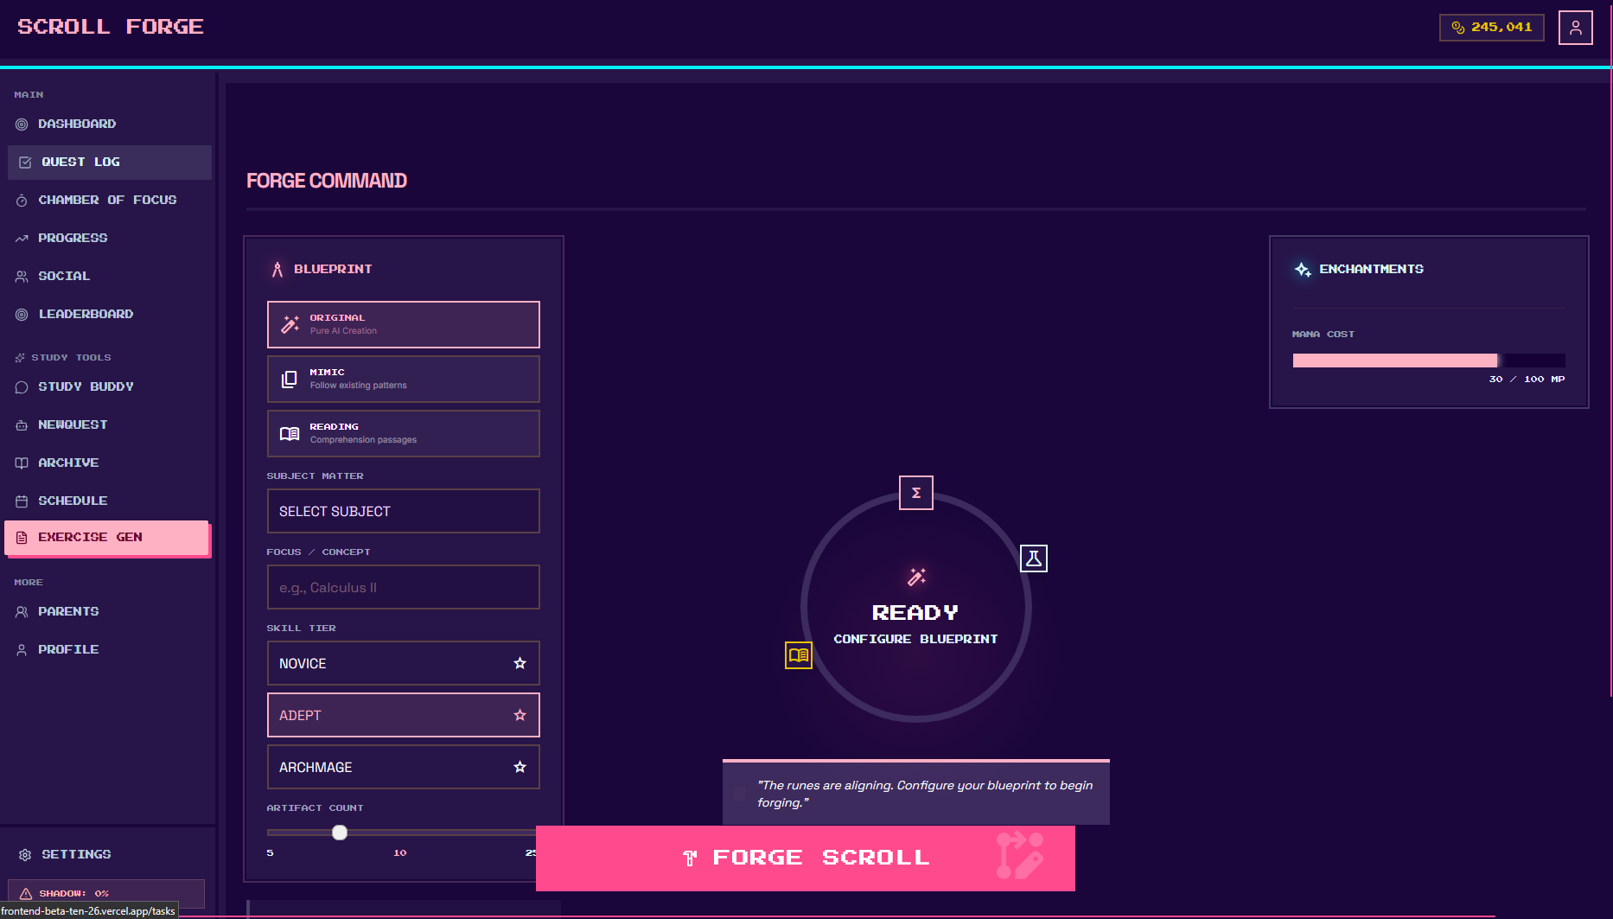
Exercise Gen (Scroll Forge) — "Generate Practice Worksheets"
What this screen does:
Create custom practice problems for any subject! Choose your topic, difficulty level, and how many questions you want. The AI generates a printable worksheet with answers. Perfect for exam revision or weak topic practice.
How to Use:

Open Exercise Gen — Tap "EXERCISE GEN" in the left menu (or "SCROLL FORGE" at the top)
Pick a Blueprint (question type):
ORIGINAL — Standard practice questions (like textbook exercises)
MIXED — Mix of easy and hard questions
RANDOM — Surprise mix of all types
Select Your Subject — Tap the "SELECT SUBJECT" box and pick:
Mathematics, Physics, Chemistry, Biology, English, etc.
Enter Focus / Concept — Type the specific topic (e.g., "Calculus II", "Quadratic Equations", "Organic Chemistry")
Choose Skill Tier (difficulty):
NOVICE — Easy questions, good for beginners or review
ADEPT — Medium difficulty, standard test level
ARCHMAGE — Hard questions, exam/challenge level
Set Question Count — Use the slider to pick how many questions (e.g., 5 to 50)
Check Mana Cost — Top right shows how much energy this will use (e.g., 20 / 100 MP)
Tap "FORGE SCROLL" — The big pink button at the bottom generates your worksheet
Download or Print — The worksheet appears as a DOCX file you can save or print

Key Buttons & Features:

BLUEPRINT buttons — Original / Mixed / Random (question style)
SELECT SUBJECT dropdown — Choose your school subject
FOCUS / CONCEPT box — Type the exact topic you want to practice
SKILL TIER stars — Novice (1 star) → Adept (2 stars) → Archmage (3 stars)
Question Count slider — Drag to set 5, 10, 20, or up to 50 questions
"READY" circle — Shows when your settings are complete
ENCHANTMENTS panel — Shows mana cost and power level
FORGE SCROLL button — Generates the worksheet (takes 10-20 seconds)

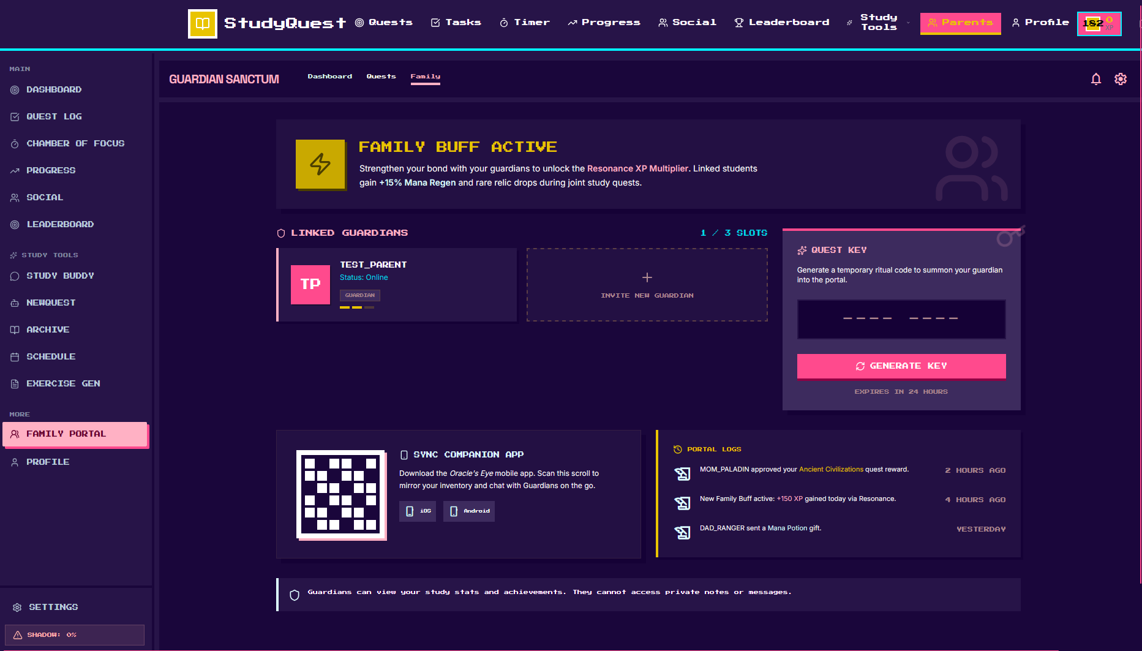
Family Portal (Guardian Sanctum) — "Link Your Parents"
What this screen does:
Connect your parents to your StudyQuest account so they can see your study progress. Don't worry — they can ONLY see your study time and achievements. They cannot read your private chats or notes!
How to Use:

Open Family Portal — Tap "FAMILY PORTAL" in the left menu
See your linked guardians — "TEST_PARENT" (Mom) is already connected and online
Check your Family Buff — Top banner shows "+15% Mana Regen" bonus just for having a parent linked! This means you recover energy faster.

To Add a New Parent/Guardian:

Tap "INVITE NEW GUARDIAN" — The box with the "+" sign
Or use Quest Key (right side):
Tap "GENERATE KEY"
A temporary 6-character code appears (like A1B2C3)
Tell your parent this code (say it out loud, text it, or write it down)
Your parent enters this code in their Parent Dashboard
The code expires in 15 minutes, so use it quickly!
Wait for parent to accept — They will appear in your "Linked Guardians" list
You can have up to 3 guardians — "1 / 3 SLOTS" means you have 2 more spots

Key Buttons & Features:

Linked Guardians list — Shows who can see your progress (Mom, Dad, etc.)
Online status — Green dot means your parent is currently using the app
INVITE NEW GUARDIAN (+) — Add another parent or family member
QUEST KEY panel — Generate the temporary linking code
GENERATE KEY button — Creates a new 6-character code (expires in 15 min)
SYNC COMPANION APP — QR code for parents to download the mobile app
iOS — Tap Apple icon for iPhone/iPad
Android — Tap Android icon for Samsung/Huawei/etc.
PORTAL LOG — Recent family activities:
"MOM_PALADIN approved your Ancient Civilizations quest reward" — 2 hours ago
"New Family Buff active: +15% gained today via Resonance" — 4 hours ago
"DAD_RANGER sent a Mana Potion gift" — Yesterday
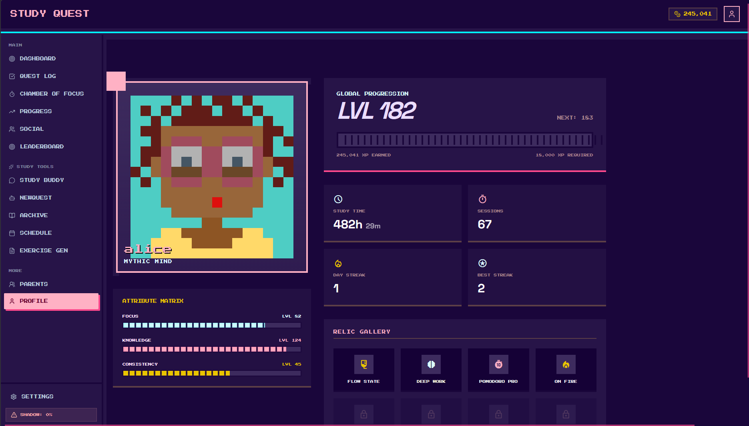
Profile — "Your Hero Identity"
What this screen does:
This is your personal profile page. See your avatar, level, total study time, and all the achievement badges (relics) you've collected. Customize how you look and track your strongest skills.
How to Use:

Open Profile — Tap "PROFILE" in the left menu
Check your Avatar (left side):
Your pixel-art character picture
"alice" — Your display name
"MYTHIC MIND" — Your current title (earned from achievements)
Tap your avatar to change your picture or username (if unlocked)
Check Global Progression (top right):
LVL 182 — Your current level (very high!)
XP Bar — Shows XP earned;
The bar fills up as you study. When it hits 100%, you level up!
Your Core Stats (middle cards):
Study Time: 482h 29m — Total time spent studying (about 20 full days!)
Sessions: 67 — Number of separate study sessions completed
Day Streak: 1 — Current consecutive days studied (study today to make it 2!)
Best Streak: 2 — Your personal record for most days in a row
Attribute Matrix (bottom left):
Your skill levels in three areas:
Focus: LVL 52 — How well you concentrate (blue bar)
Knowledge: LVL 124 — How much you've learned (pink bar) — Your strongest!
Consistency: LVL 45 — How regularly you study (yellow bar)
These levels increase automatically as you study
Relic Gallery (bottom right):
Your earned achievement badges:
FLOW STATE — Gold shield (earned for deep concentration)
DEEP WORK — Eye icon (earned for long study sessions)
POMODORO PRO — Timer icon (earned for using 25-minute sessions)
ON FIRE — Flame icon (earned for maintaining streaks)
Locked slots below — Complete more quests to unlock these!
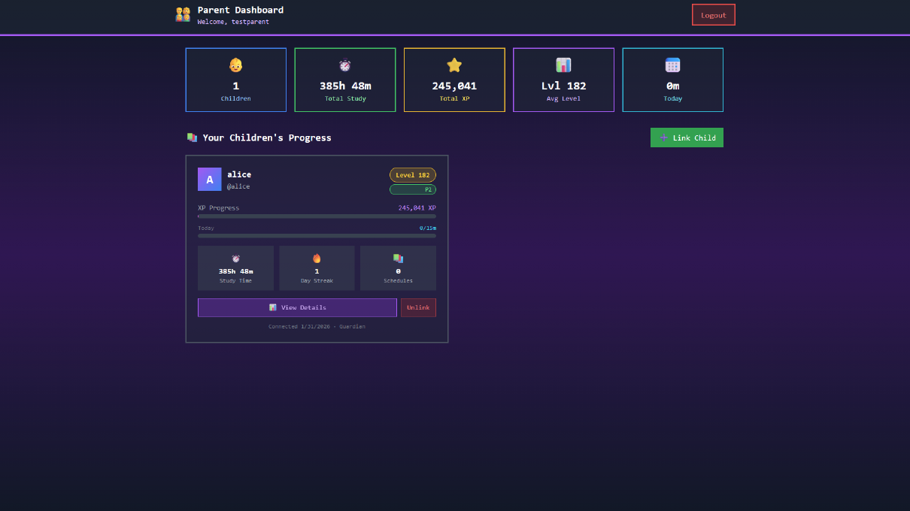
Parent Dashboard — "Monitor Your Child's Progress"
What this screen does:
This is the parent view. See how much your child is studying, their current level, and daily progress — all without asking "Did you do your homework?" every day. The data updates automatically when your child uses the app.
How to Use:

Log in as Parent — Use your parent account (e.g., testparent)
See the summary (top row):
1 Children — Number of kids linked to your account
385h 48m Total Study — Combined study time across all linked children
245,041 Total XP — Combined experience points earned
Lvl 182 Avg Level — Average level of your children
0m Today — How much studied today so far (updates in real-time)
Link a New Child:
Tap the green "+ Link Child" button
Ask your child to open their Family Portal and tap "Generate Key"
Type the 6-character code your child gives you
Tap confirm — you will see their card appear here
Read Your Child's Card:
alice — Your child's display name
Level 182 — Their current rank in the game
P2 — Parent tier (your subscription/engagement level)
XP Progress: 245,041 XP — Total points earned from studying
Today: 0/15m — Daily goal progress (0 minutes out of 15-minute target)
Study Time: 385h 48m — Lifetime hours studied
Day Streak: 1 — Consecutive days studied (1 = studied yesterday, not today yet)
Schedules: 0 — Number of AI-generated study plans active
Tap "View Details" — See deeper stats:
Weekly study charts
Subject breakdown (which subjects they study most)
Recent achievements and badges earned
AI tutor conversation history (what they asked for help with)
Tap "Unlink" — Remove access to this child's data (if needed)

Key Buttons & Features:

Logout — Top right. Sign out of parent account
Link Child — Add another son or daughter to monitor
View Details — Purple button to see full report for that child
Unlink — Red button to disconnect (child must approve re-linking later)
Connected date — Shows when you first linked (e.g., "1/31/2026")

